**Annex 1 – Confidentiality Agreement**

This Agreement is between TORRY HARRIS BUSINESS SOLUTIONS PVT. LTD. and BHAGWATI PRASAD TIWARI

As an employee or subcontractor of a supplier to BT, you may have access to BT information or BT computer systems.

We require you: -

1. to keep all BT information (whether or not it is marked "INTERNAL", “IN CONFIDENCE”, or “IN STRICTEST CONFIDENCE”) confidential and not to disclose it to any third party, unless BT has given its written permission for such disclosure;
2. if you have access to BT customer or personal information, to comply with the provisions of any applicable Data Protection law;
3. to access BT computer systems and BT electronic information only if you have been authorised to do so. Unauthorised access may result in your being prosecuted and/or legal actions (including disciplinary) being taken against you;
4. to access and use BT computer systems and BT information only as is necessary to do your job properly;
5. to comply with other BT instructions and security policies that may be notified from time to time by us; and
6. not to connect any equipment not supplied by BT to any BT LAN port.

If you are in any doubt as to these requirements or BT Group Information and Physical Security policies, further information can be obtained from Farooq Syed Mehboob (+44-7989771846) or your BT contact. Farooq Syed Mehboob and/or your BT contact can also supply copies of the policies should you not have access to them.

Any breach of these requirements will be treated seriously and could result in the cessation of your assignment and/or legal action.

**Personal Declaration**

I have read and understand the above requirements and agree to be bound by them.

Signed 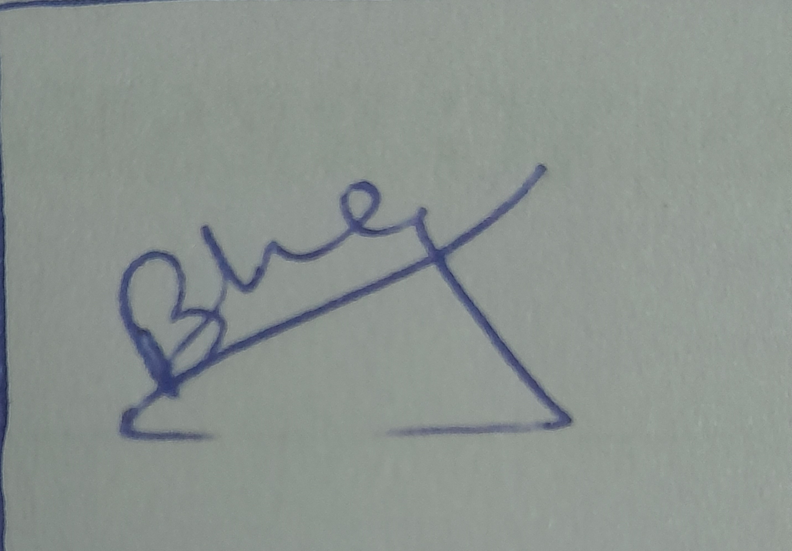 Date:17/02/2022

Print full name and home address:

Name BHAGWATI PRASAD TIWARI

Address

­­­­­­­­­­­­­­­­­­­s/o chandi prasad tiwari,

Ward no-08,koti athurwala,

Dehradun,Uttarakhand-248202